Title: No More Than Four Lines
Department: Head
Editor: Name, xxxx@email

F. A. Author
First Affiliation
B. Author, Jr.
Second Affiliation
C. Author, III
Third Affiliation

Abstract—Abstract text goes here. This single paragraph (≤200 words) summarizes the significant aspects of the manuscript. Often it indicates whether the manuscript is a report of new work, a review or overview, or a combination of thereof. Do not cite references in the abstract. Papers must not have been published previously, must fit into the theme of an open Call for Papers, and must be targeted toward the general technical reader. This journal provides early access to all full manuscript submissions; if your paper is not cleared at the time you submit your full paper for peer review, please alert the IEEE Admin. CS Magazine authors will need to obtain official IEEE Computer Society clearance for publication. During the editorial/production process, IEEE Publications, Editorial Services, will provide production services throughout the publication process.

THE INTRODUCTION should provide back- ground information (including relevant references) and should indicate the purpose of the manuscript. Cite relevant work by others, including research outside your company. Place your work in perspective by referring to other research papers. Inclusion of statements at the end of the introduction regarding the organization of the manuscript can be helpful to the reader.
This document is a template for docx. If you are reading a paper or PDF version of this document, please download the electronic file, CsMag_template.docx, from the IEEE Web site at http://www.ieee.org/authortools/ so you can use it to prepare your manuscript.

COPYRIGHT AND CLEARANCE
All CS Magazine authors must obtain clearance from IEEE Computer Society before sub- mitting the final manuscript. The “Publication Clearance” wiki provides details about the procedure. Computer Society employees must use the Scholar One Manuscripts Clearance System to obtain publication approval.

FONTS
Helvetica-Light and Cheltenham-Book must be installed.

SECTIONS
Sections following the introduction should present your results and findings. The body of the paper should be approximately 6,000 words. The manuscript should evolve so that each sentence, equation, figure, and table flow smoothly and logically from whatever precedes it. Relevant work by others, as well as relevant products from other companies, should be adequately and accurately cited. Sufficient support should be provided (or cited) for the assertions made and conclusions drawn.
Headings may be numbered or unnumbered (“1 Introduction” and “1.2 Numbered level 2 head”), with no ending punctuation. As demonstrated in this document, the initial paragraph after a heading is not indented.

JOURNAL STYLE
Use American English when writing your paper. The serial comma should be used (“a, b, and c” not “a, b and c”). In American English, periods and commas are within quotation marks, like “this period.” Other punctuation is “outside”! The use of technical jargon, slang, and vague or informal English should be avoided. Generic technical terms should instead be used.

Acronyms and abbreviations
All acronyms should be defined at first mention in the abstract and in the main text. Define in figures, tables, and footnotes only if not defined in the discussion of the figure/table. Acronyms consist of capital letters (except where salted with lowercase), but the terms they represent need not be given initial caps unless a proper name is involved (“central processing unit” [CPU] but “Fourier transform” [FT]). Use of “e.g.” and “i.e.” okay, but refrain from using “etc.” It is preferable to use these abbreviations only in parentheses (e.g., like this).
Abbreviate units of time (s, min, hr, day, mo, yr) only in virgule constructions (10 µg/hr) and in artwork; otherwise, spell out, e.g., 10 days, 3 months, 25 minutes. Units of measure (Kb, MB, kWh, etc.) should always be abbreviated when used with a numeral. If used alone, spell out (“16 MB of RAM” but “these values are measured in micrometers”).

Numbers
Spell out numerals that have no unit of mea- sure or time (one, two, ...ten), but always use numerals with units of time and measure. Some examples are as follows: 11 through 999; 1,000; 10,000; twentieth century; twofold, tenfold, 20-fold; 2 times; 0.2 cm; p = .001; 25%; 10% to 25%.

MATH AND EQUATIONS
If you are using Word, use either the Microsoft Equation Editor or the MathType add-on (http://www.mathtype.com) for equations in your brief (Insert | Object | Create New | Microsoft Equation or MathType Equation). “Float over text” should not be selected.
Scalar variables and physical constants should be italicized, and a bold (non-italics) font should be used for vectors and matrices. Do not italicize subscripts unless they are variables.
Equations should be either display (with a number in parentheses) or inline.
Display equations should be flush left and numbered consecutively, with equation numbers in parentheses and flush right.
Be sure the symbols in your equation have been defined before the equation appears or immediately following. Please refer to “Equation (1),” not “Eq. (1)” or “equation (1).”
Punctuate display equations when they are part of the sentence preceding it, as in
$A=πr^{2}$ (1)
In addition, if the text following the equation flows logically as a part of the display equation,
$$a^{2}+b^{2}=c^{2}$$
use ending punctuation (comma) after the display equation.

LISTS
Avoid using lists. Instead, use full sentences and flowing paragraphs. If you absolutely must use a list, use them rarely and keep them short:
- Style for bulleted lists—This is the style that should be used for bulleted lists.
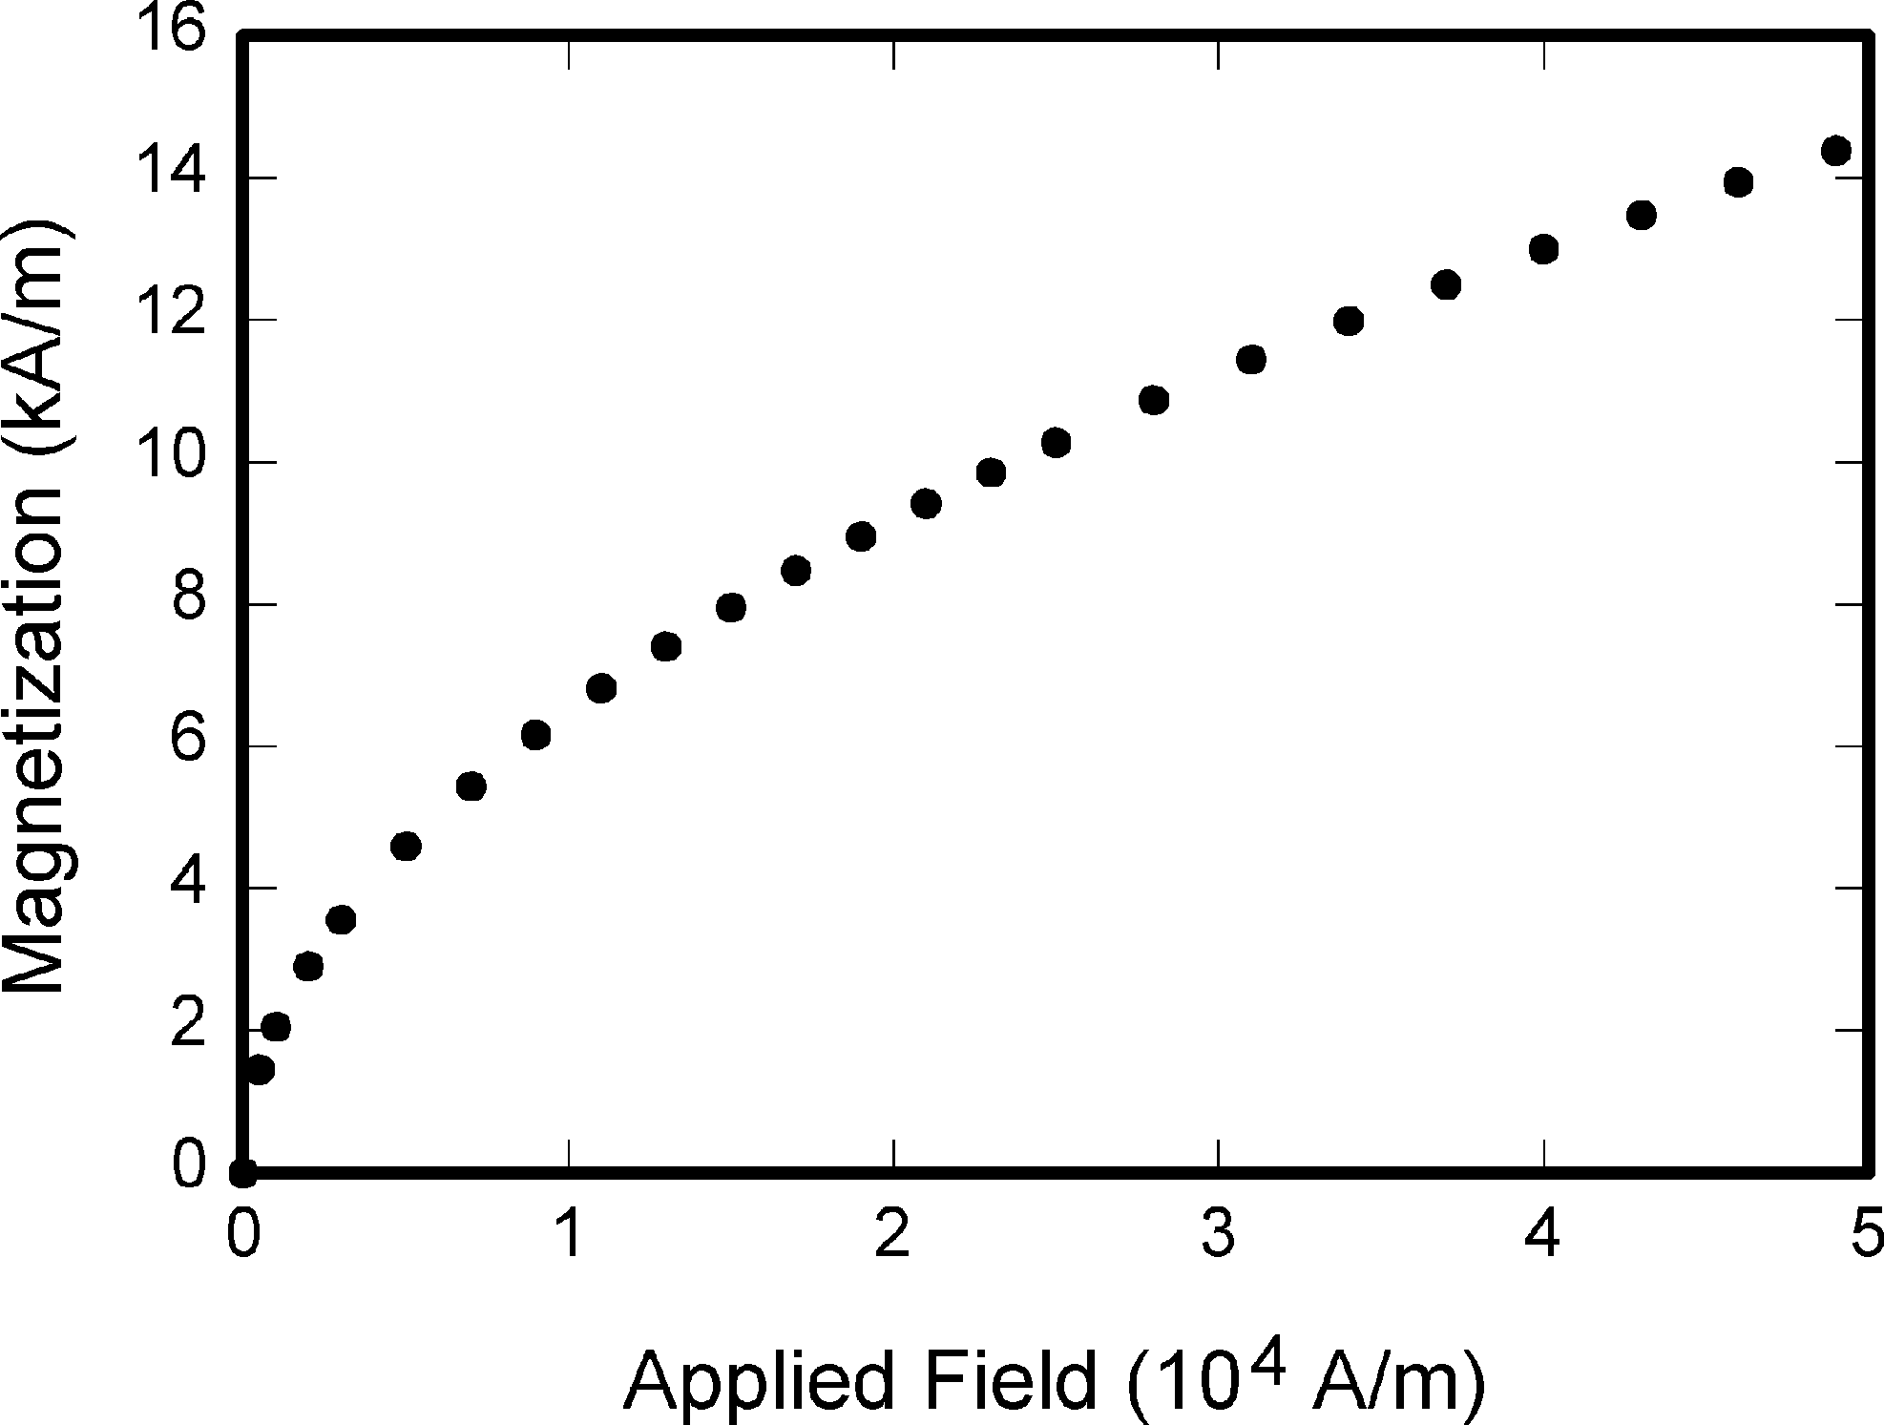
Figure 1. Note that “Figure” is spelled out. There is a period after the figure number, followed by one space. It is good practice to briefly explain the significance of the figure in the caption. (Used, with permission, from [4].)
- Punctuation in lists—Each item in the list should end with a period, regardless of whether full sentences are used.

GRAPHICAL ABSTRACTS
This journal accepts graphical abstracts, and they must be peer reviewed, which means the graphical abstract must be submitted with the full paper. graphical abstracts and their specifications. Please read the additional information provided by IEEE about graphical abstracts.

FIGURES AND TABLES

In-text callouts for figures and tables
Figures and tables must be cited in the running text in consecutive order. At first mention, the ci- tation should be boldface (Figure 1); subsequent mentions should be Roman type (see Figure 1 and Table 1). Figure 2 shows an example of a figure spanning across two columns.
Table 1. Units for magnetic properties.
Symbol | Quantity | Conversion from  Gaussian and CGS EMU to SIa
Φ | Magnetic flux | 1 Mx → 10⁻⁸ Wb
B | Magnetic flux density, magnetic induction | = 10⁻⁸ V · s  1 G → 10⁻⁴ T  = 10⁻⁴ Wb/m2
H | Magnetic field strength | 1 Oe → 10⁻³/(4π)  A/m
m | Magnetic moment | 1 erg/G = 1 emu
 |  | → 10⁻³ A ·
M | Magnetization | m2 = 10⁻³ J/T  1 erg/(G · cm3) = 1
 |  | emu/cm3 → 10⁻³
 |  | A/m
4πM | Magnetization | 1 G → 10⁻³/(4π)
 |  | A/m
Vertical lines are optional in tables. Statements that serve as captions for the entire table do not need footnote letters. aGaussian units are the same as cg emu for magnetostatics; Mx = maxwell, G = gauss, Oe = oersted; Wb = weber, V = volt, s = second, T = tesla, m = meter, A = ampere, J = joule, kg = kilogram, H = henry.
Previously published figures or tables require permission to reprint. Please obtain permission. Then, add the following text to the figure/table caption: “From [reference no.], with permission,” or “Adapted from [reference no.], with permis- sion.” Carefully explain each figure in the text. Each manuscript should be limited to four figures.

Appendices
If multiple appendices are required, they should labeled “Appendix A,” “Appendix B,” etc. They appear before the “Acknowledgment” or the “References” section.

Acknowledgment
The “Acknowledgment” (no’s) section appears immediately after the conclusion. If applicable, this is where you indicate funding for the work. The preferred spelling of the word “acknowledgment” in American English is without an “e” after the “g.” Avoid expressions such as “One of us (S.B.A.) would like to thank...” Instead, write “We thank....” Sponsor and financial support acknowledgments are included in the acknowledgment section. For example: This work was supported in part by the U.S. Department of Commerce under Grant BS123456 (sponsor and financial support acknowledgment goes here). Researchers that contributed information or assistance to the article should also be acknowledged in this section. Also, if corresponding authorship is noted in your paper it will be placed in the acknowledgment section. Note that the acknowledgment section is placed at the end of the paper before the reference section.
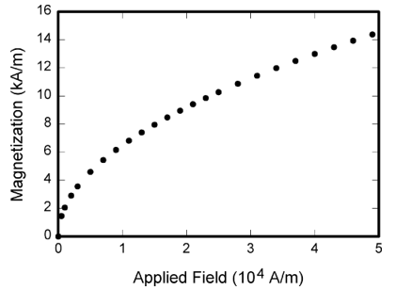
Figure 2. Note that “Figure” is spelled out. There is a period after the figure number, followed by one space. It is good practice to briefly explain the significance of the figure in the caption. (Used, with permission, from [4].)

References
References need not be cited in text. When they are, they appear on the line, in square brackets, inside the punctuation. Multiple references are each numbered with separate brackets. When citing a section in a book, please give the relevant page numbers. In text, refer simply to the reference number. Do not use “Ref.” or “reference” except at the beginning of a sentence: “Reference [3] shows....” Please do not use automatic endnotes in Word, rather, type the reference list at the end of the paper using the “References” style.
Reference numbers are set flush left and form a column of their own, hanging out beyond the body of the reference. The reference numbers are on the line, end with period. In all references, the given name of the author or editor is abbreviated to the initial only and precedes the last name. Use them all; use et al. only if names are not given. Use commas around Jr., Sr., and III in names. Abbreviate conference titles. When citing IEEE transactions, provide the issue number, page range, volume number, year, and/or month if available. When referencing a patent, provide the day and the month of issue, or application. References may not include all information; please obtain and include relevant information. Do not combine references. There must be only one reference with each number. If there is a URL included with the print reference, it can be included at the end of the reference.
Other than books, capitalize only the first word in a paper title, except for proper nouns and element symbols. For papers published in translation journals, please give the English citation first, followed by the original foreign- language citation See the end of this document for formats and examples of common references. For a complete discussion of references and their formats, see the IEEE style manual at http://www.ieee.org/authortools.

CONCLUSION
The manuscript should include a conclusion. In this section, summarize what was described in your paper. Future directions may also be included in this section. Authors are strongly encouraged not to reference multiple figures or tables in the conclusion; these should be referenced in the body of the paper.
ACKNOWLEDGMENT
We thank A, B, and C. This work was sup- ported in part by a grant from XYZ.
REFERENCES
1. G. M. Amdahl, G. A. Blaauw, and F. P. Brooks, “Architecture of the IBM System/360,” IBM J. Res. & Dev., vol. 8, no. 2, pp. 87–101, 1964. (journal)
2 IBM Corporation, IBM Knowledge Center - IBM Secure Service Container (Secure Service Container). [Online].Available: https://www.ibm.com/support/ knowledgecenter/en/HW11R/com.ibm.hwmca.kc se.doc/ introductiontotheconsole/wn2131zaci.html (URL)
3. J. Williams, “Narrow-band analyzer,” PhD dissertation, Dept. of Electrical Eng., Harvard Univ., Cambridge, MA: 1993. (Thesis or dissertation)
4 J. M. P. Martinez, R. B. Llavori, M. J. A. Cabo, et al., “Integrating data warehouses with web data: A survey,” IEEE Trans. Knowledge and Data Eng., preprint, Dec. 21, 2007, doi:10.1109/TKDE.2007.190746. (PrePrint)
5. W.-K. Chen, Linear Networks and Systems, Belmont, CA: Wadsworth, pp. 123–135, 1993. (book)
6. S. P. Bingulac, “On the compatibility of adaptive con- trollers,” Proc. Fourth Ann. Allerton Conf. Circuits and Systems Theory, pp. 8–16, 1994. (conference proceedings)
7. K. Elissa, “An overview of decision theory,” unpublished. (Unpublished manuscript)
8. R. Nicole, “The last word on decision theory,” J. Computer Vision, submitted for publication. (Pending publication)
9. C. J. Smith and J. S. Smith, Rocky Mountain Re- search Laboratories, Boulder, CO, personal communication, 1992. (Personal communication)

First A. Author current employment (is currently with XYZ Corporation, New York, NY, USA). Author’s latest degree received or which he/she is currently pursuing (He received the B.S. degree and the M.S. degree....”). Author’s research interest. Association with any official journals or conferences; major professional and/or academic achievements, i.e., best paper awards, research grants, etc.; any publication information (number of papers and titles of books published). Author membership information, e.g., is a member of the IEEE and the IEEE Computer Society, if applicable, is noted at the end of the biography. Biography is limited to single paragraph only (He is a member of IEEE, etc.). All biographies should be limited to one paragraph, five to six sentences, consisting of the following: (e.g., “Dr. Author received a B.S. degree and an M.S. degree ....”), including years achieved; association with any official journals or conferences; major professional and/or academic achievements, i.e., best paper awards, re- search grants, etc.; any publication information (number of papers and titles of books published); current research interests; association with any professional associations. Author membership information, e.g., is a member of the IEEE and the IEEE Computer Society, if applicable, is noted at the end of the biography. Contact him/her at faauthor@xyz.com.
Second B. Author, Jr., is with ABC Corporation, Bblingen, Germany. Ms. Author’s biography appears here. Contact him/her at sbauthor@abc.com.
Third C. Author, III, is with DEF Corporation, Tokyo, Japan. Dr. Author’s biography appears here. Contact him/her at tcauthor@def.com.

Digital Object Identifier XXXXXXXX

